Name of the Student: G. Manasa | Academic Year: 2025-26
Student Registration Number: 241U1R3007 | Year & Term: II & I
Study Level: UG | Class & Section: CSE-DS-2A
Name of the Course: Startup management | Name of the Instructor: Ms. Meghna Bandi
Name of the Assessment: study report | Date of Submission: 21-09-2025

Study Report
Executive Summary (main findings at a glance)
- Sample size: 84 respondents.
- Most consumed type of milk: Packaged/Branded milk (52 respondents, 61.90%).
- Top factor influencing choice: Purity/Quality (69 selections, 82.14% — multiple answers allowed).
- Label-checking behaviour: Majority always or sometimes check labels — Always: 48 (57.14%), Sometimes: 25 (29.76%).
- Primary purchase concern: Nutritional value (32; 38.10%) and Purity & absence of adulteration (30; 35.71%) are the two leading single-choice concerns.
- Willingness to pay extra for guaranteed pure milk: Yes — 62 respondents (73.81%), No — 22 (26.19%).

Question-wise analysis

1) What type of milk do you usually consume?
Option | Count | Percentage
Packaged / Branded milk | 52 | 61.90%
Loose / Unpackaged milk | 16 | 19.05%
Both | 16 | 19.05%

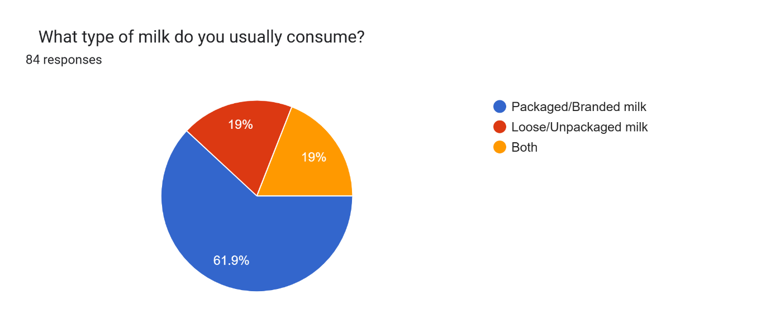
Insight: Packaged/branded milk is the dominant choice (roughly 62%), while about 38% either consume loose milk or both. This suggests a strong market for branded packaged milk but a sizeable segment remains for loose milk.
2) What factors influence your choice of milk? (multiple answers allowed)
Factor | Count | % of respondents (n=84)
Purity / Quality | 69 | 82.14%
Price | 27 | 32.14%
Taste | 23 | 27.38%
Brand Reputation | 15 | 17.86%
Availability | 13 | 15.48%

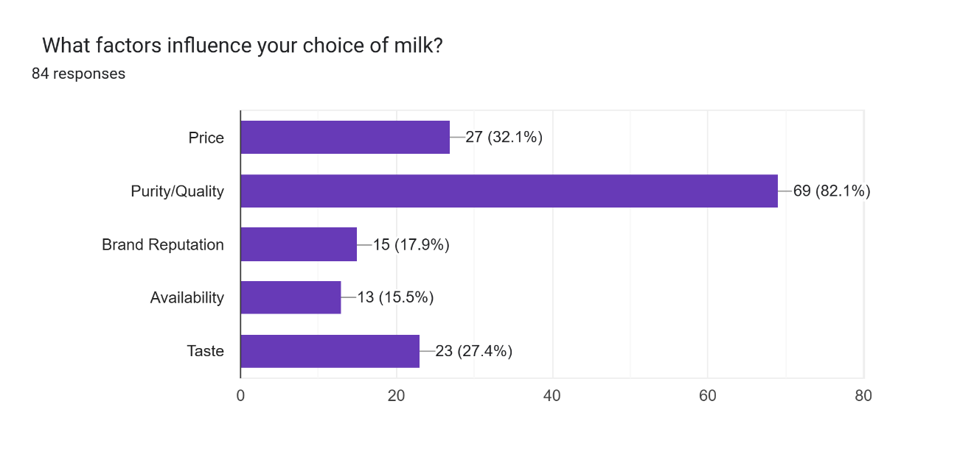
Insight: Purity/quality is overwhelmingly the most common factor (82%). Price and taste matter to about a third and a quarter respectively. Brand reputation and availability are less frequently cited. This suggests marketing and operations should prioritize demonstrable purity/quality measures first.
3) Do you check labels or certifications before buying milk?
Option | Count | Percentage
Always | 48 | 57.14%
Sometimes | 25 | 29.76%
Rarely | 8 | 9.52%
Never | 3 | 3.57%

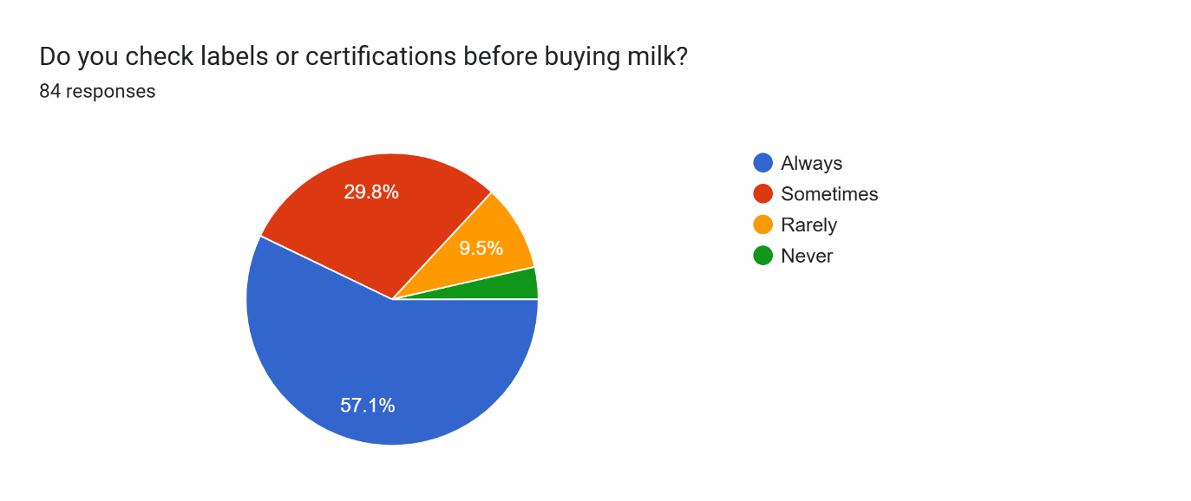
Insight: A large majority (about 87% combined Always/Sometimes) give at least some importance to label/certification information. This aligns with the prominence of purity/quality as a decision driver.
4) Which of the following best describes your primary concern while purchasing milk? (single choice)
Concern | Count | Percentage
Nutritional value | 32 | 38.10%
Purity & absence of adulteration | 30 | 35.71%
Price & affordability | 14 | 16.67%
Availability & convenience | 4 | 4.76%
Brand reputation | 4 | 4.76%

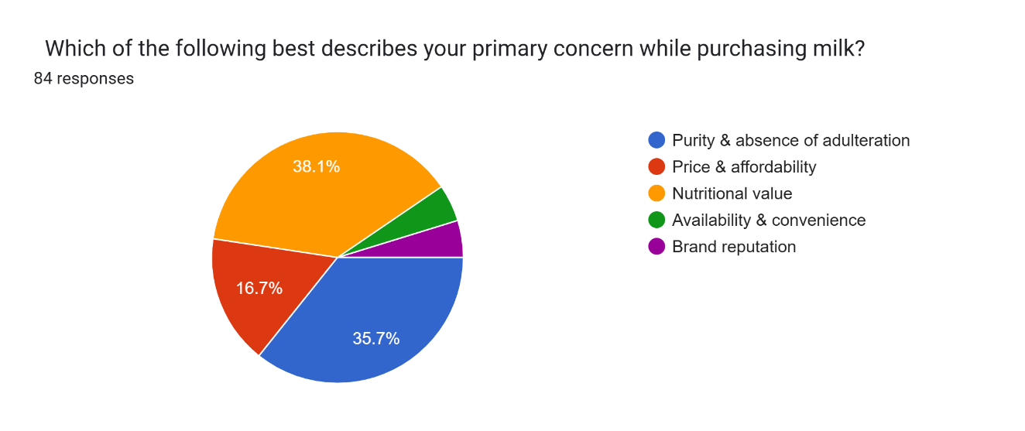
Insight: Nutritional value slightly edges out purity as the top single concern, though both are nearly equally important. Price is a secondary concern for most respondents.

5) Would you be willing to pay extra for guaranteed pure milk (with certifications and lab testing)?
Option | Count | Percentage
Yes | 62 | 73.81%
No | 22 | 26.19%

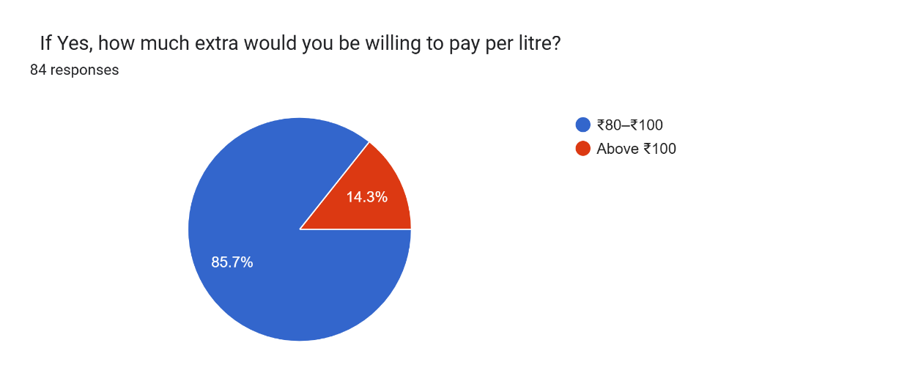
Insight: A large majority say they would pay extra for guaranteed pure milk — a strong signal that premiumization anchored to certification and lab-testing could be commercially viable.
6) If Yes, how much extra would you be willing to pay per litre?
- Data not provided / missing in the content you pasted. No counts or amounts were included.
- Recommendation: Ask respondents to select from preset bands (e.g., ₹0–₹5, ₹6–₹10, ₹11–₹20, >₹20) or provide a numeric entry; share the responses and I’ll analyze willingness-to-pay (WTP) distribution and estimate price elasticity.
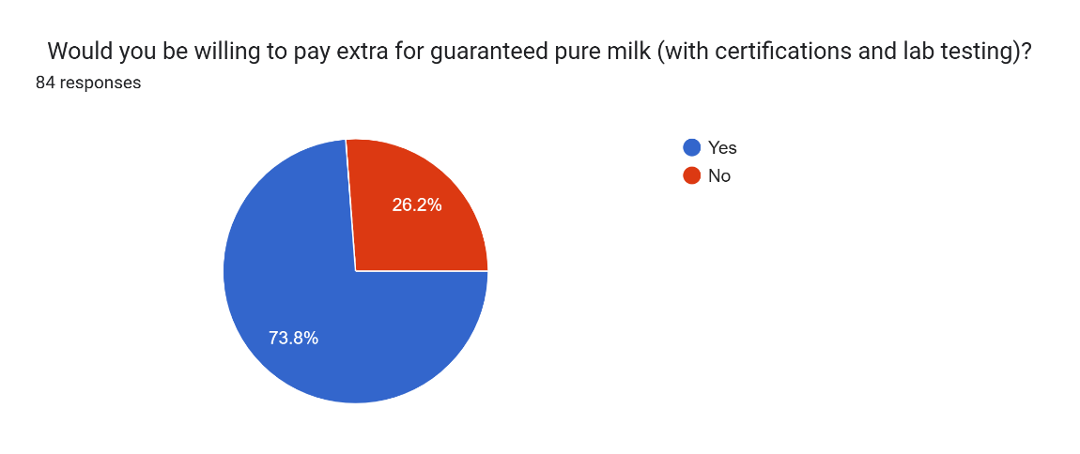

Key takeaways
- Trust and purity drive purchase decisions. Purity/quality is the top multi-select factor (82.1%), and purity/adulteration is a top single concern (35.7%).
- Packaged/branded milk leads market share among respondents (61.9%), implying consumers prefer the perceived safety/convenience of packaged milk.
- Labeling and certifications matter. 57.1% always check labels and another 29.8% sometimes do — companies can leverage labeling/certs to influence choices.
- Willingness to pay for verified purity is high. About 73.8% say they would pay extra for guaranteed pure milk — an opportunity for premium products backed by third-party testing/certification.
- Price still matters but is secondary. Price is selected by ~32% as a factor and 16.7% cite price as the primary concern — meaning price sensitivity exists but is not the dominant barrier for most.
- Taste and brand reputation play a role for a minority; availability impacts relatively few respondents directly.
Recommendations
Product & quality
- Develop a certified “pure milk” premium line with clear lab-testing details on packaging (date of test, lab name, certification logo). Given 73.8% willingness to pay and 82.1% citing purity, this is likely to attract early adopters.
- Provide quick verification cues on pack (QR code linking to lab certificate and batch test results). Since ~87% check labels (always/sometimes), this will build trust.

Pricing & packaging
- Introduce tiered pricing: base branded product for price-sensitive customers and a premium authenticated product for those willing to pay extra. (You asked the WTP question but data’s missing — run a follow-up with price bands to quantify premium price points.)
- Smaller trial-size packs (500 ml) for premium pure product to reduce purchase friction and let customers test before committing.
Marketing & positioning
- Lead with purity and nutrition messaging: emphasize lab tests, absence of adulterants, and nutritional value in advertising. Use testimonials and demonstrable proof.
- Educate consumers about how certifications work and what they mean — short infographics on pack or social media since many do check labels.
Distribution & availability
- Ensure availability in channels used by packaged milk buyers (neighborhood grocery, modern trade, and online grocery). Availability was a lower-factor but still relevant.
- Consider partnerships with local credible labs and display their logos.
Research & follow-up actions
- Collect the missing WTP numeric/band data to estimate optimal premium pricing.
- Add demographic questions (age, household size, income, location) to future surveys to segment preferences and target marketing.
- Segment analysis: if you can share the raw export (CSV/XLSX), I can produce segment-level cross-tabs e.g., preference by age or by whether they check labels.

